**MATHEMATICS FOR COMPUTING**

***WEEK 2 - SEMINAR***

**FUNCTIONS, MODULE ARITHMETIC AND SURDS**

**Learning Outcomes**

By the end of the seminar the successful student will be able to:

* Basic concepts of function
* Working with modular arithmetic - addition and multiplication
* Understanding surds

**Lecture Recap**

1. A [relation](https://mathinsight.org/definition/relation) from a set of inputs to a set of possible outputs where each input is related to exactly one output.
2. True b) False
3. **What is the classic way of writing a function?**
4. *f ( x )* b) *f = ( x )* c) (fx)
5. **What are the three main parts?**
6. The input, the relationship, the output
7. Output only
8. Input only
9. **The tree grows 20cm every year, so the height of the tree is related to its age. Describe it using function.**
10. h=age X 20b) h(age)=age X 20 c) age=h(20)
11. **What would be the name of the function if *f (x) = x2* ?**

Ans: f

1. Look at the following picture. Is it OK in a function?

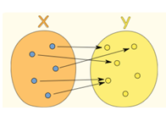

1. Yes b) No
2. **Fill in the blanks:**

A linear function is an equation that describes a _____________ on a graph.

1. Curve b) Straight line c) None of them
2. **Which of the linear equation given below is Slope and Y-Intercept?**

**y = mx + b**

1. m is slope, x is Y-Intercept b) m is Y-Intercept, b is slope

c) m is slope, b is Y-Intercept

1. **All quadratic equations can be written in the form of**
2. ax2+bx+c=0 b) x2+ax+c=0 c) cx2+bx+a=0

# Linear Equations - Standard Form

# Linear equations have a standard form that looks like this: *Ax + By = C*

# In order to graph a linear equation you can put in numbers for x and y into the equation and plot the points on a graph. One way to do this is to use the "intercept" points. The intercept points are when x = 0 or y = 0. Here are some steps to follow:

# Plug x = 0 into the equation and solve for y

# Plot the point (0,y) on the y-axis

# Plug y = 0 into the equation and solve for x

# Plot the point (x,0) on the x-axis

# Draw a straight line between the two points.

# Task 1:

# Graph the linear equation in standard form: 2x + y = 2

# Step 1: Plug in x = 0 and solve for y.

# 2 (0) + y = 2

# y = 2

# Step 2: Plug in y = 0 and solve for x.

# 2x + 0 = 2

# 2x = 2

# x = 1

# Step 3: Graph the x and y intercept points (0, 2) and (1, 0)

# Step 4: Draw a straight line through the two points

# https://www.ducksters.com/kidsmath/linear_equations1.gif

# Step 5: Check the answer.

# We will put in 2 for x and solve:

# 2(2) + y = 2

# 4 + y = 2

# y = 2 – 4

# y=-2

# Is the point (2,-2) on the line?

# You can try some other points to double check as well.

# Exercise Task 1:

# Graph the linear equation x - 2y = 2

# Check your answer after found X and Y coordinates,

Let's try x = 4

Is the point (4, 1) on the graph?

# Linear Equations – Point Slope Form

The equation looks like this:

***y - y1 = m(x - x1)***

# Task 2:

Graph a line that passes through the coordinate (2,2) and has a slope of 3/2. Write the equation in the slope-intercept form.

See the graph below. First we plotted the point (2,2) on the graph. Then we found another point using a rise of 3 and a run of 2. We drew a line between these two points.

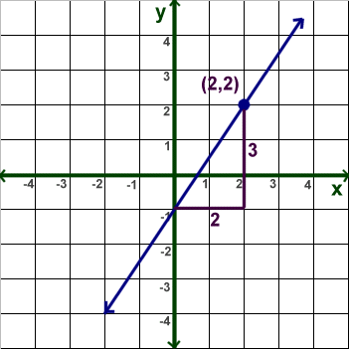

To write this equation in slope-intercept form we use the equation:

y = mx + b

We already know that the slope (m) = 3/2 from the question. The y-intercept (b) we can see is at -1 from the graph. We can fill in m and b to get the answer:

**y = 3/2x -1**

**Quadratic Equations**

### Task 3

### Solve 5x2 + 6x + 1 = 0

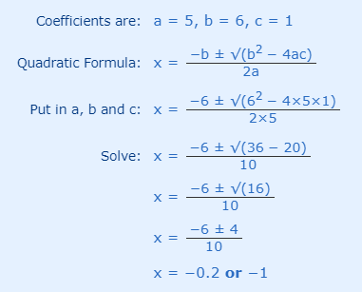

**Answer: x = −0.2 or x = −1**

And we see them on this graph.

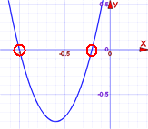

|  |  |  |
| --- | --- | --- |
| Check **-0.2**: |  | 5×(**−0.2**)2 + 6×(**−0.2**) + 1 = 5×(0.04) + 6×(−0.2) + 1 = 0.2 − 1.2 + 1 **= 0** |
| Check **-1**: |  | 5×(**−1**)2 + 6×(**−1**) + 1 = 5×(1) + 6×(−1) + 1 = 5 − 6 + 1 **= 0** |

**Exercise Task 2:**

Solve: x2 + 7x + 12 = 0

# Modular Arithmetic

**Modular Addition**

# 

# Task 4

Find the sum of 31 and 148 in modulo 24.

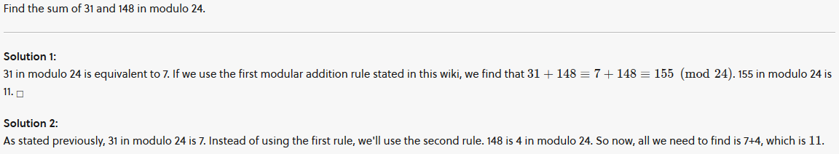

# Task 5

### Find the remainder when 123 + 234 + 32 + 56 + 22 + 12 + is divided by 3.

# 

**Exercise Task 3**

## Find the sum of 71 and 269 in modulo 21.

## Modular Multiplication

Modular multiplication appears in many fields of mathematics and has many far-ranging applications, including cryptography, computer science, and computer algebra.

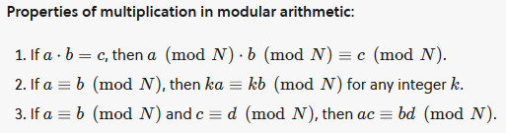

**Task 6**

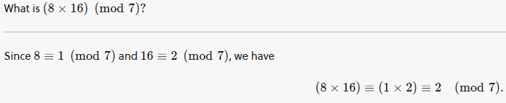

**Task 7**

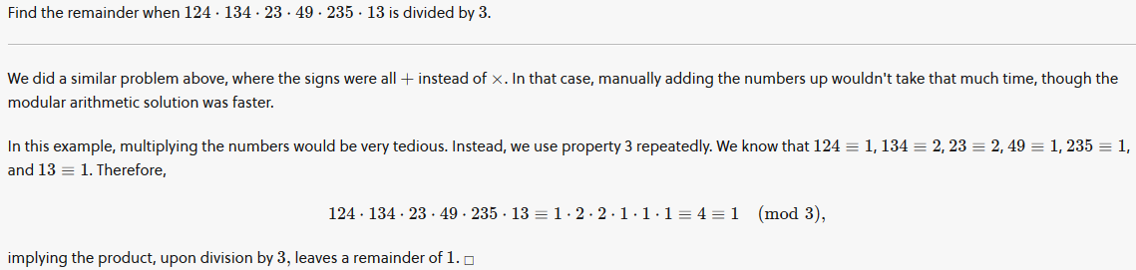

**Exercise Task 4:**

Find the remainder when 224⋅164⋅43⋅330⋅24 is divided by 6.

**Surds**

When we can't simplify a number to remove a square root (or cube root etc) then it is a surd.

* Example 1: √2 (square root of 2) can't be simplified further so it is a **surd**
* Example 2: √4 (square root of 4) **can** be simplified (to 2), so it is **not a surd**!

Have a look at some more examples:

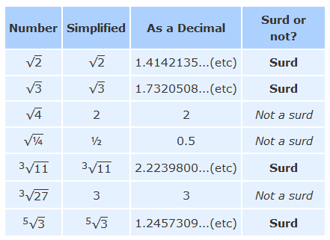

**Homework Task:**

## Find the remainder when 223 + 134 + 62 + 76 + 29 + 32 + is divided by 5.

1. What is (12 X 14) (mod 8)?

**References**

1. <https://en.wikipedia.org/wiki/Function_(mathematics)>
2. <https://www.khanacademy.org/math/algebra/x2f8bb11595b61c86:functions>
3. <https://nrich.maths.org/4350>
4. <https://mathworld.wolfram.com/ModularArithmetic.html>
5. <https://artofproblemsolving.com/wiki/index.php/Modular_arithmetic/Introduction>
6. <https://www.youtube.com/watch?v=d-n92Ml1iu0>
7. <https://www.youtube.com/watch?v=568dGLFTom8>